**Architecture Diagram:**

**C:\Program Files (x86)\Microsoft Office\MEDIA\CAGCAT10\j0292020.wmfSender**

Encrypt the Text

Secret Data

Register & Login

Split and Stored in QR Code

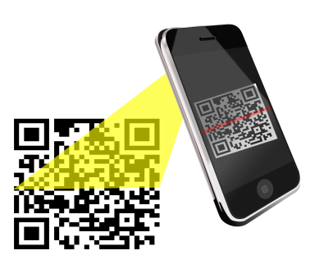 **Receiver**

Receive Shares and Merge the QR Code